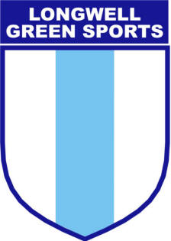
Formed 1966
Respect Code of Conduct For Spectators and Parents/Carers
We all have a responsibility to promote high standards of behaviour in the game. This club is supporting The FA’s Respect programme to ensure football can be enjoyed in a safe, positive environment. Remember children’s football is a time for them to develop their technical, physical, tactical and social skills. Winning isn’t everything. Play your part and observe The FA’s Respect Code of Conduct for spectators and parents/carers at all times.

I will:

• Remember that children play for FUN
• Applaud effort and good play as well as success
• Respect the rights, dignity and worth of each and every player
• Avoid criticising a player for making a mistake – mistakes are part of learning
• Encourage the players to respect the opposition, referee and match officials
• Always respect the match officials’ decisions
• Remain outside the field of play and within the Designated Spectators’ Area (where provided)
• Let the coach do their job and not confuse the players by telling them what to do
• Place the well-being and safety of each player above all other considerations, including the development of performance
•Consistently display high standards of behaviour

I understand that if I do not follow the Code, any/all of the following actions may be taken by my club, County FA, league or The FA:

I may be:

• Issued with a verbal warning from a club or league official
• Required to meet with the Club, Principle or County FA Welfare Officer
• Required to meet with the club committee
• Obliged to undertake an FA education course
• Obliged to leave the match venue by the club
• Requested by the club not to attend future games
• Suspended or have my club membership removed
• Required to leave the club along with any dependents.

In addition:

• The FA/County FA could impose a fine and/or suspension on the club.

